**Exercise:**

**1. Correct poorly documented code**

The provided code snippet performs a data analysis task but lacks proper documentation, comments, and variable labels. Your task is to enhance the code by adding comments, providing clear variable names, and improving readability. Rewrite the code to make it more understandable for future collaborators.

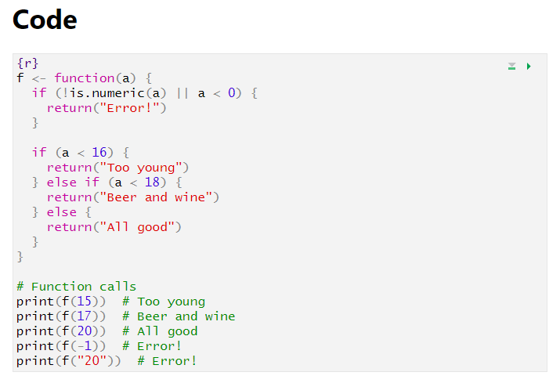**Questions:**

1. Identify at least three issues with the provided code example in terms of documentation and variable naming.
2. Why is it important to have clear and descriptive variable names in code for reproducible research?
3. How does adding comments to code contribute to the reproducibility of research?

**2. Rework of last weeks code**

Take a look at your code from last week and enhance its readability and reproducibility. Things to look out for could be

1. Look at variable names. Are they self-explanatory?
2. Place comments in places where they are needed